POWER MANAGEMENT BOARD

Features:

* Supplies Power to different subsystems
* Multiple Voltage rails:

- 3V3

- 5V

- 7V

* Battery Voltage Monitoring
* Protected Outputs

Requirements:

* MCU

- ESP32 S2 Wroom

* To regulate voltage

- Buck Convertors IC

- Resistors

- Inductors

- Capacitors

* Power

- Battery

* Battery Monitoring

- Resistors

- ADC pin of MCU

* Protection of Cameras

- Fuses and Mosfets

* For Flashing Code

- C-type USB (SMD)

- Diodes

* For Output

-Screw Terminals

DESIGN: 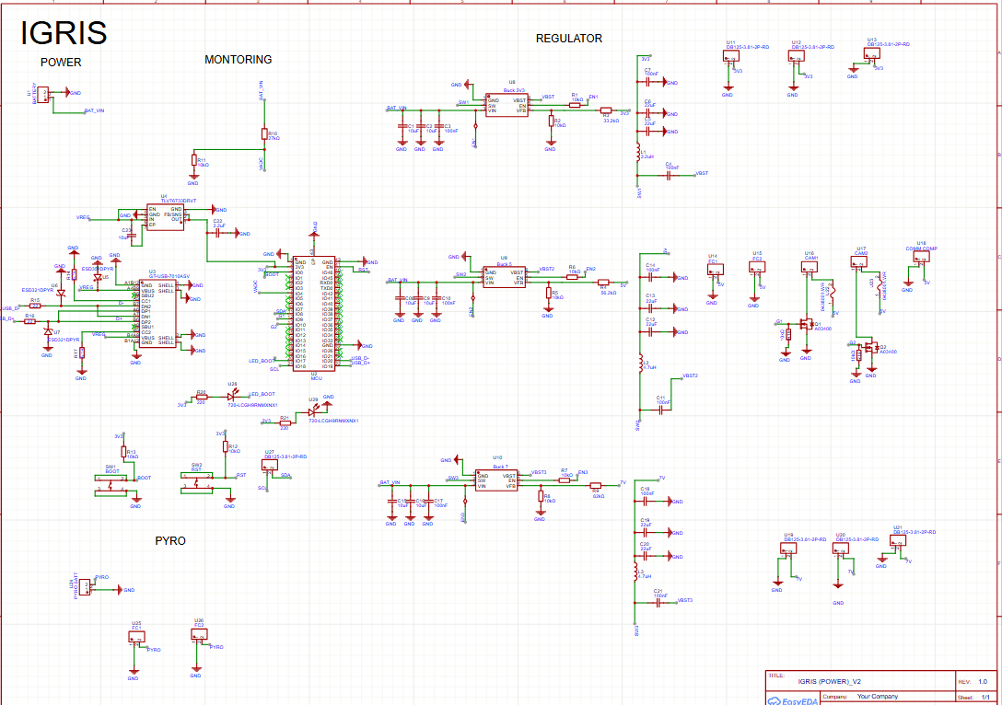

PCB:

